 

**INSTITUTE FOR ADVANCED COMPUTING ANDSOFTWARE DEVELOPMENT (IACSD), AKURDI, PUNE**

Documentation On

Gym-Genie

PG-DAC March 2023

# Submitted By:

**Group No: 32**

**Roll No. Name:**

**233061 Rohit Phulari**

**233178 Malhar Patil**

# Mrs. Gauri Kadam Mr. Rohit Puranik

**Project Guide Centre Coordinator**

# ABSTRACT

This project is a web-based gym management system for an existing gym. The project objective is to manage the gym tasks from website.

The system is an attempt to provide the advantages of online managing and storing data of the gym. It helps to stay updated and manage the gym activities or data from anywhere through internet by using a website device. Thus, without using paper or pen or gathering all the gym members in the ,one can get updated using the website portal.

This will beneficial to all the members who are unable to visit the gym for time being. Also for gym owner to manage all his records without much documentation. Making it online will be feasible and flexible and try to make it user friendly.

# ACKNOWLEDGEMENT

I take this occasion to thank God, almighty for blessing us with his grace and taking our endeavor to a successful culmination. I extend my sincere and heartfelt thanks to our esteemed guide, **Mrs.Gauri Kadam** for providing me with the right guidance and advice at the crucial juncture sand for showing me the right way. I extend my sincere thanks to our respected **Centre Co-Ordinator Mr. Rohit Puranik**, for allowing us to use the facilities available. I would like to thank the other faculty members also, at this occasion. Last but not the least, I would like to thank my friends and family for the support and encouragement they have given me during the course of our work.

#### Rohit Phulari (233061)

**Malhar Patil (233178)**



# Table of Contents

ABSTRACT 1

ACKNOWLEDGEMENT 2

INTRODUCTION 6

FEATURES 6

* 1. PROJECT OBJECTIVE 7
  2. PROJECT OVERVIEW 7
  3. PROJECT SCOPE 8
  4. STUDY OF THE SYSTEM 8
     1. MODULES 8

SYSTEM ANALYSIS 12

* 1. EXISTING SYSTEM 12
  2. PROPOSED SYSTEM 12
  3. SYSTEM REQUIREMENT SPECIFICATION 12
     1. GENERAL DESCRIPTION 13
     2. SYSTEM OBJECTIVES 13
     3. SYSTEM REQUIREMENTS 13

SYSTEM DESIGN 15

* 1. INPUT AND OUTPUT DESIGN 15
     1. INPUT DESIGN 15
     2. OUTPUT DESIGN 15

GIT REPOSITORY LINKS…………………………………………………………………..16

DATABASE DESIGN 17

* 1. DATABASE 17
  2. SYSTEM TOOLS 17
     1. FRONT END 17
     2. BACKEND 17

1. LEVEL DFD 18
2. LEVEL DFD FOR GYM OWNER 19

1 LEVEL DFD FOR TRAINER 20

1 LEVEL DFD FOR GYM MEMBER 21

# Table of Contents

E-R DIAGRAM 22

CLASS DIAGRAM 23

TABLE STRUCTURE 24

SEQUENCE DIAGRAM……………………………………………………………………… 26

USER CASE DIAGRAM……………………………………………………………………… 27

PROJECT DIAGRAMS 28

FUTURE PROJECT SCOPE…………………………………………………………………. 49

CONCLUSION 50

REFERENCES 51

E-R DIAGRAM 22

CLASS DIAGRAM 23

TABLE STRUCTURE 24

SEQUENCE DIAGRAM……………………………………………………………………… 26

USER CASE DIAGRAM……………………………………………………………………… 27

PROJECT DIAGRAMS 28

FUTURE PROJECT SCOPE…………………………………………………………………. 49

CONCLUSION 50

REFERENCES 51

**LIST OF FIGURES**

#### FIGURE 1: ADMIN (GYM OWNER) ACTIVITY DIAGRAM 9

**FIGURE 2: TRAINER ACTIVITY DIAGRAM 10**

#### FIGURE 3: GYM MEMBER ACTIVITY DIAGRAM 11

**FIGURE 4: 0 LEVEL DFD 18**

#### FIGURE 5: 1 LEVEL DFD FOR ADMIN (GYM OWNER) 19

**FIGURE 6: 1 LEVEL DFD FOR TRAINER 20**

#### FIGURE 7: 1 LEVEL DFD FOR GYM MEMBER 21

**FIGURE 8: E-R DIAGRAM 22**

#### FIGURE 9: CLASS DIAGRAM 23

**FIGURE 10: TABLE STRUCTURE 24**

**FIGURE 11: SEQUENCE DIAGRAM-------------------------------------------------------------------- 26**

**FIGURE 12:USER CASE DIAGRAM--------------------------------------------------------------------- 27**

**FIGURE 13: PROJECT DIAGRAMS 28**

# INTRODUCTION

Gyms are the essential part of our lives, providing best exercise and body building facilities to our society. Therefore, at the management end there are some necessary steps to maintain the records of every individual including trainer, gym members, and admin but maintaining the records on paper is very difficult. So it is necessary to have a computerized system that manages all these functionality. Thus working on the management system for Gym Industry is the basis of our project.

The web based “Gym Management System” project is an attempt to simulate basic concepts of gym management system. The system enables the member to do the things such as search for workout-plans, diet plans and choose them based on the details of the plans.

The system provides a facility that provides details about gym contact details with locations, Gallery, Programs and Blogs. But if user wants to book plan then he/she must login into his/her account.

The system allows the gym-members to search for subscription-plans, workout-plans and diet-plans which are provided by the management. The system displays all the plan’s details such as plan-Id, plan- Name, duration and amount. Services provided by Gym are also handled by this system

## Features: -

1. Separate login for Gym owner ,Trainer and User.
2. Easy to add or update the trainer information by Owner.
3. Easy to keep data of all the plans like diet plan and workout plan.
4. Easy to choose diet plan for gym member.
5. Date and time of registering of user is automatically generated.
6. Easy to keep update of plans.
7. Owner can easily assign any plan to gym member or also add or delete gymtrainer.

## PROJECT OBJECTIVE

The main functionality of this system is for user is that he can see and browse through different plans available at the gym also he can browse through gallery images and decide if he wants to join the gym or not. For owner it is helpful for maintaining all the data about trainer and different plans.

## PROJECT OVERVIEW

The application is designed into three modules first one is the gym owner who has full access to the application. Second one is the gym trainer who can add diet plan and workout plan. Third module is gym member who can register and subscribe for diet plan and workout plan.

Owner gives limited access to gym trainer and gym member and owner has full access to either add or delete or update any plan and gym trainer. Owner also can see who has visited the site and who has taken membership. Owner can also remove any member and trainer.

Trainer will be able to register himself on the site as trainer and he/she can add his specific plans for himself.

User after logging in can see information about gym and he can fill up gym membership form for the membership after that he will be able to see list of diet plans and workout plans and choose about them. User can also see contact information different blogs which are posted on site from time to time.

## PROJECT SCOPE

This system provides friendly user interface to every member of the gym. The various other functionalities

Depends on the authority. This system will be available 24/7 for all the regions. This system will help all sectors of people which will provide them visibility and smooth functioning. This will be beneficial to all the members who travel worldwide and any members will an access to it. Understanding the needs of the gym members and to overcome the manual work of the documentation and make it online which will be feasible and flexible and try to make it user friendly.

## STUDY OF THE SYSTEM

## MODULES:

The system after careful analysis has been identified to be presented with the following modules and roles.

The modules involved are:

* + - * Admin (Gym Owner)
      * Gym Trainer
      * Gym Member

1.4.1.1:Admin:

The Admin is the super user of this application. Only Admin have access into this Admin page. Admin is the owner of the gym . The Admin has all the information about the other members such as gym trainer and gym member.

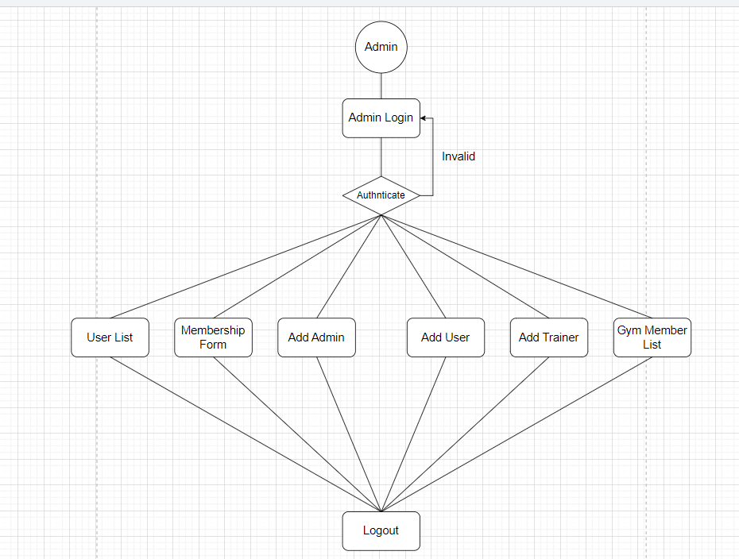

Fig.1 Admin activity diagram

1.4.1.2:Gym Trainer:

The trainer can register himself/herself on the site as a trainer.

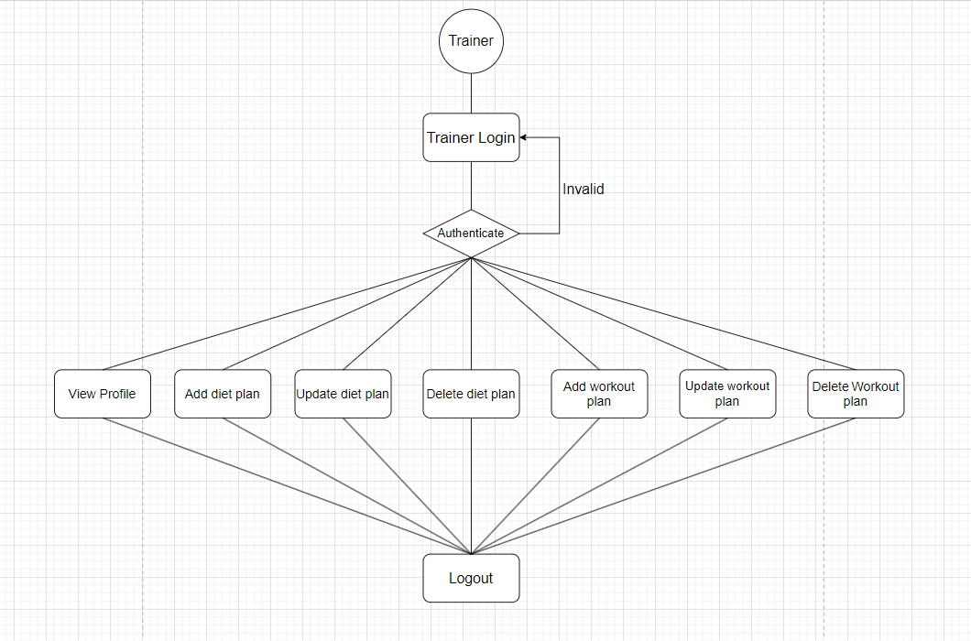

Fig.2 Trainer activity diagram

1.4.1.3:Gym member:

Any user except Admin and trainer can become gym member by filling membership form available after logging in.

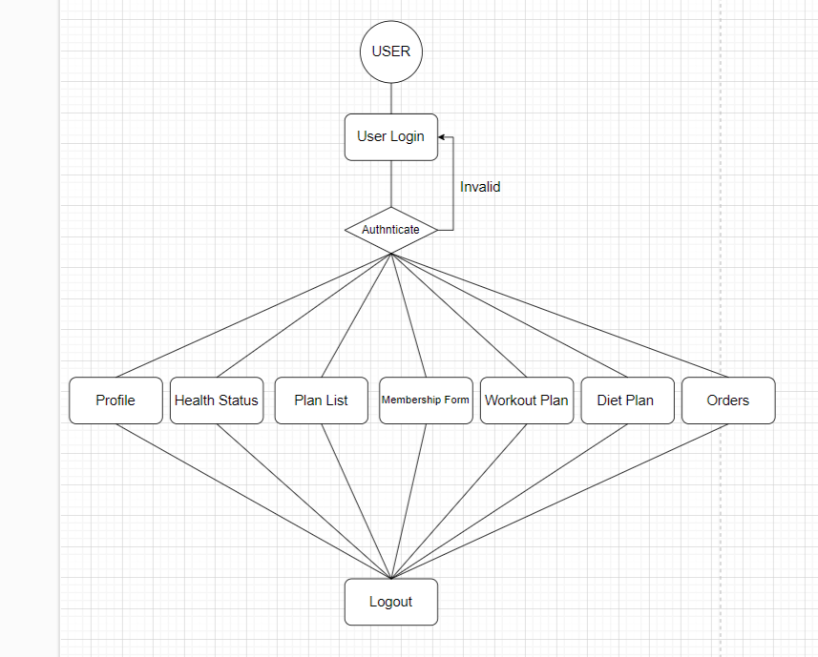

Fig.3 User Activity diagram

# SYSTEM ANALYSIS

System analysis is the process of gathering and interpreting facts, diagnosing problems, and using the information to recommend improvements on the system. System analysis is a problem-solving activity that requires intensive communication between the system users and system developers.

System analysis or study is an important phase of any system development process. The system is viewed as a whole, the inputs are identified, and the system is subjected to close study to identify the problem areas. The solutions are given as a proposal. The proposal is reviewed on user request and suitable changes are made. This loop ends as soon as the user is satisfied with the proposal.

## EXISTING SYSTEM

The current system for gym management is maintain pen and paper data to add new owner of the gym or trainer or gym member. To subscribe to any membership user has to go to gym personally.

* + - It is less user-friendly.
    - Gym owner has to meet each member of the gym and give full description of plans and all other things.
    - It is difficult to gather every member of gym at once.
    - Gym owner has to maintain all the documentation about gym trainers and gym members as well as different plans such as gym membership plan, diet plan, workout plan.
    - It is a time-consuming process
    - Not in reach of distant users.

## PROPOSED SYSTEM

The proposed system provides friendly user interface to every member of the gym. This application will help all sectors of people which will provide them visibility and smooth functioning. This will be beneficial to all the members who travel abroad and who cannot be a part of each and every notice of the gym. This application will travel worldwide and any members will have an access to it. Understanding the needs of the gym members and to overcome the manual work of the documentation and make it online which will be feasible and flexible and try to make it user friendly. Web-platform means that the system will be available for access 24/7 except when there is a temporary server issue which is expected to be minimal.

## SYSTEM REQUIREMENT SPECIFICATION

#### GENERAL DESCRIPTION

**Product Description:**

The Gym Management System allows members to login with their own account and get updated with happenings in the gym. Gym Management System is the website portal to manage gym efficiently. The system has automated functionality for calculating body mass index and member can view their subscription status on their account.

#### Problem Statement:

As online management became a trend nowadays the regular activities. Gym owner and trainers have to update data which is time consuming. Gym owner has effortless managing experience and saving time through management online. For easy access with those online systems, if gym owner, trainer and gym member are providing an online portal where they manage their tasks through internet and get up to date information.

#### SYSTEM OBJECTIVES

* + - * To provide a Web site for online gym management for an existing gym.

#### SYSTEM REQUIREMENTS

* + - 1. **NON-FUNCTIONAL REQUIREMENTS**

#### EFFICIENCY REQUIREMENT

When gym owner or trainer or user visits system it should access in an efficient manner.

#### RELIABILITY REQUIREMENT

The system should provide a reliable environment to gym owner and user. All data should be store on server.

#### USABILITY REQUIREMENT

The Web application is designed for user friendly environment and ease of use.

#### IMPLEMENTATION REQUIREMENT

Implementation of the system using React in front end with Spring Boot as back end and it will be used for database connectivity. And the database part is developed by MySQL. Responsive web designing is used for making the website compatible for any type of screen.

#### DELIVERY REQUIREMENT

The whole system is expected to be delivered in four months of time with a weekly Evaluation by the project guide.

* + - 1. **FUNCTIONAL REQUIREMENTS**

#### Functional Requirement

* Login Portal for admin, trainer, user, gym member.
* Admin has all control over the functionality like add, remove, view, update details of trainer, diet plan and workout plan.
* Admin should generate plan and display or write blogs on website.
* Admin has access to assign plans to trainer.
* Gym member should view only his profile.
* Gym member should access all the plans available.
* Gym member should be able to choose any plan from given plans.
* Gym member should be able to see diet plans and workout plans and choose among them.

# SYSTEM DESIGN

System design is the solution for the creation of a new system. This phase focuses on the detailed implementation of the feasible system. Its emphasis on translating design. Specifications to performance specification. System design has two phases of development.

* Logical Design
* Physical Design

During logical design phase the analyst describes inputs (sources), outputs(destinations), databases (data sores) and procedures (data flows) all in a format that meets the user requirements. The analyst also specifies the needs of the user at a level that virtually determines the information flow in and out of the system and the data resources. Here the logical design is done through data flow diagrams and database design. The physical design is followed by physical design or coding. Physical design produces the working system by defining the design specifications, which specify exactly what the candidate system must do. The programmers write the necessary programs that accept input from the user, perform necessary processing on accepted data and produce the required report on a hard copy or display it on the screen.

## INPUT AND OUTPUT DESIGN

#### INPUT DESIGN:

Input design is the link that ties the information system into the world of its users. The input design involves determining the inputs, validating the data, minimizing the data entry and provides a multi-user facility. Inaccurate inputs are the most common cause of errors in data processing. Errors entered by the data entry operators can be controlled by input design. The user-originated inputs are converted to a computer-based format in the input design. Input data are collected and organized into groups of similar data. Once identified, the appropriate input media are selected for processing. All the input data are validated and if any data violates any conditions, the user is warned by a message. If the data satisfies all the conditions, it is transferred to the appropriate tables in the database. In this project the student details are to be entered at the time of registration. A page is designed for this purpose which is user friendly and easy to use. The design is done such that users get appropriate messages when exceptions occur.

#### OUTPUT DESIGN:

Computer output is the most important and direct source of information to the user. Output design

is a very important phase since the output needs to be in an efficient manner. Efficient and intelligible output design improves the system relationship with the user and helps in decision making. Allowing the user to view the sample screen is important because the user is the ultimate judge of the quality of output. The output module of this system is the selected notifications.

* **GIT REPOSITORY LINKS:**

Rohit Phulari:

<https://github.com/Rohitphulari/Gym-Genie.git>

Malhar Patil:

<https://github.com/mxlhxr55/Gym-Genie.git>

# DATABASE DESIGN

* 1. **DATABASE(Version 8.0)**

Databases are the storehouses of data used in the software systems. The data is stored in tables inside the database. Several tables are created for the manipulation of the data for the system. Two essential settings for a database are

* Primary key - the field that is unique for all the record occurrences
* Foreign key - the field used to set relation between tables Normalization is a technique to avoid redundancy in the tables.

## SYSTEM TOOLS

The various system tools that have been used in developing both the front end and the back end of the project are being discussed in this chapter.

#### FRONT END(Version 17.0):

React is a library which is developed by Facebook are utilized to implement the frontend. React (also known as React.js or ReactJS) is a [free and open-source](https://en.wikipedia.org/wiki/Free_and_open-source_software) [front-end](https://en.wikipedia.org/wiki/Free_and_open-source_software) [JavaScript](https://en.wikipedia.org/wiki/JavaScript_library) [library](https://en.wikipedia.org/wiki/JavaScript_library) for building [user interfaces](https://en.wikipedia.org/wiki/User_interfaces) or UI components. It is maintained by [Facebook](https://en.wikipedia.org/wiki/Facebook%2C_Inc) and a community of individual developers and companies. React can be used as a base in the development of [single](https://en.wikipedia.org/wiki/Single-page_application) [page](https://en.wikipedia.org/wiki/Single-page_application) or mobile applications. However, React is only concerned with state management and rendering that state to the [DOM,](https://en.wikipedia.org/wiki/Document_Object_Model) so creating React applications usually requires the use of additional libraries for routing, as well as certain client-side functionality.

#### BACKEND:

The back end is implemented using MySQL which is used to design databases.

#### MySQL(Version 8.0):

MySQL is the world's second most widely used open-source relational database management system (RDBMS). The SQL phrase stands for Structured Query Language.

#### Spring-Boot:

This is used to connect MYSQL and fetch data from database and store the data in database. The Spring Framework is a[n application framework](https://en.wikipedia.org/wiki/Application_framework) and [inversion of control container](https://en.wikipedia.org/wiki/Inversion_of_control) for the [Java](https://en.wikipedia.org/wiki/Java_platform) [platform.](https://en.wikipedia.org/wiki/Java_platform) The framework's core features can be used by any Java application, but there are extensions for building web applications on top of the [Java EE](https://en.wikipedia.org/wiki/Java_EE) (Enterprise Edition) platform. Although the framework does not impose any specific [programming model,](https://en.wikipedia.org/wiki/Programming_model) it has become popular in the Java community as an addition to the [Enterprise JavaBeans](https://en.wikipedia.org/wiki/Enterprise_JavaBeans) (EJB) model. The Spring Framework is Open-source Framework.

# 0 Level DFD

# 

***Figure 4 0 Level DFD***

# 

# 1 Level DFD for Admin

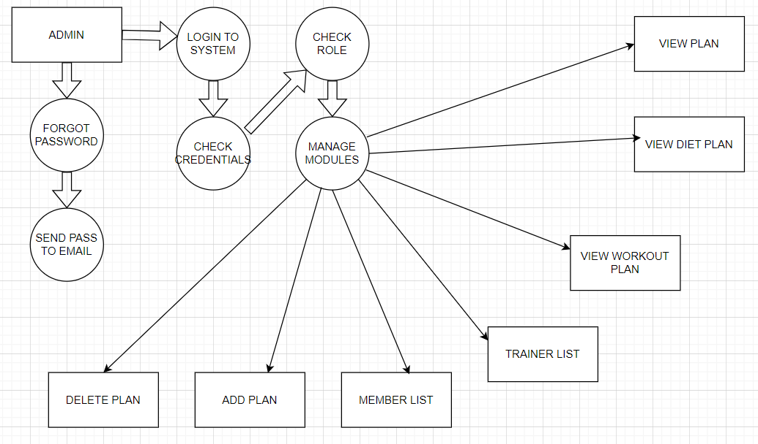

***Figure 5 1 Level DFD for Admin***

# 1 Level DFD for Trainer

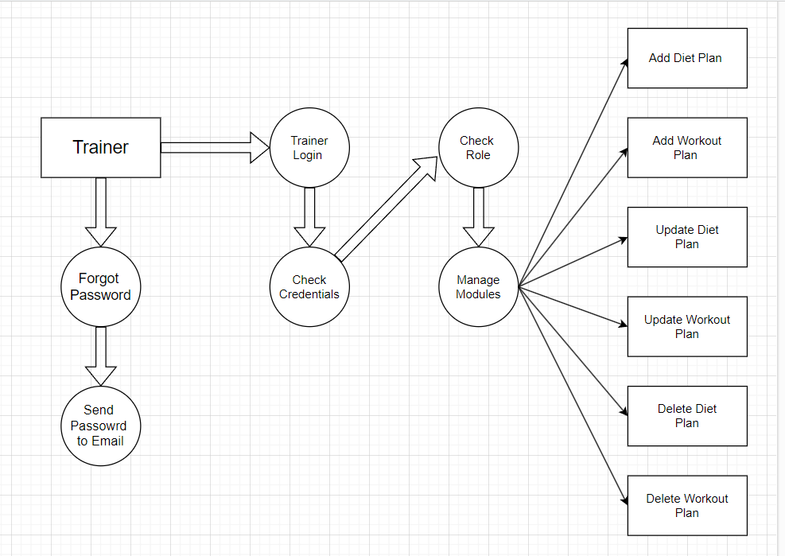

***Figure 6 1 Level DFD for Trainer***

# 1 Level DFD for Gym Member

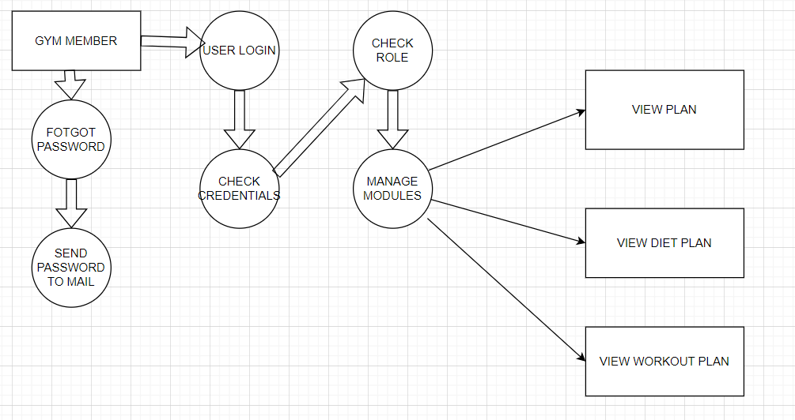

***Figure 7 1 Level DFD for Gym Member***

# E-R Diagram:

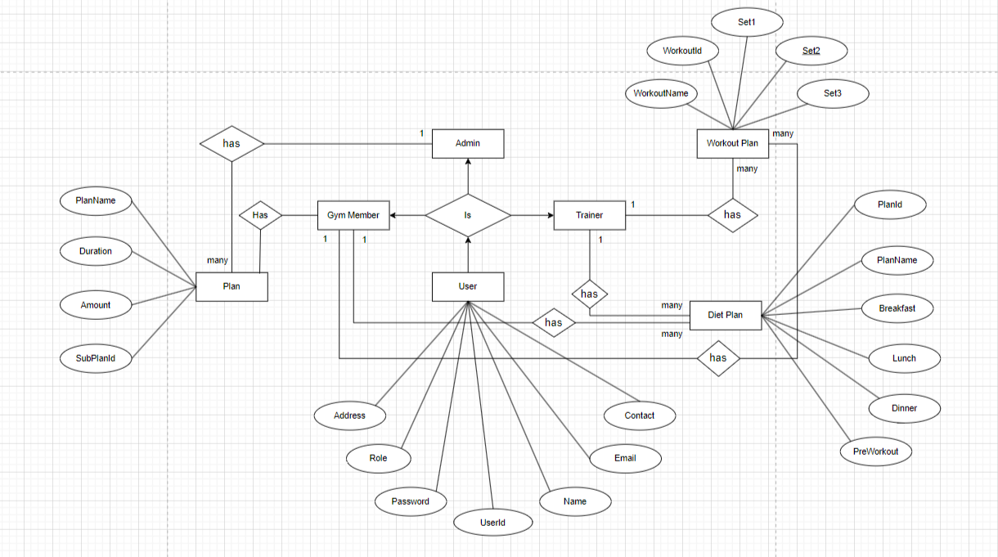

***Figure 8 E-R Diagram***

# Class Diagram

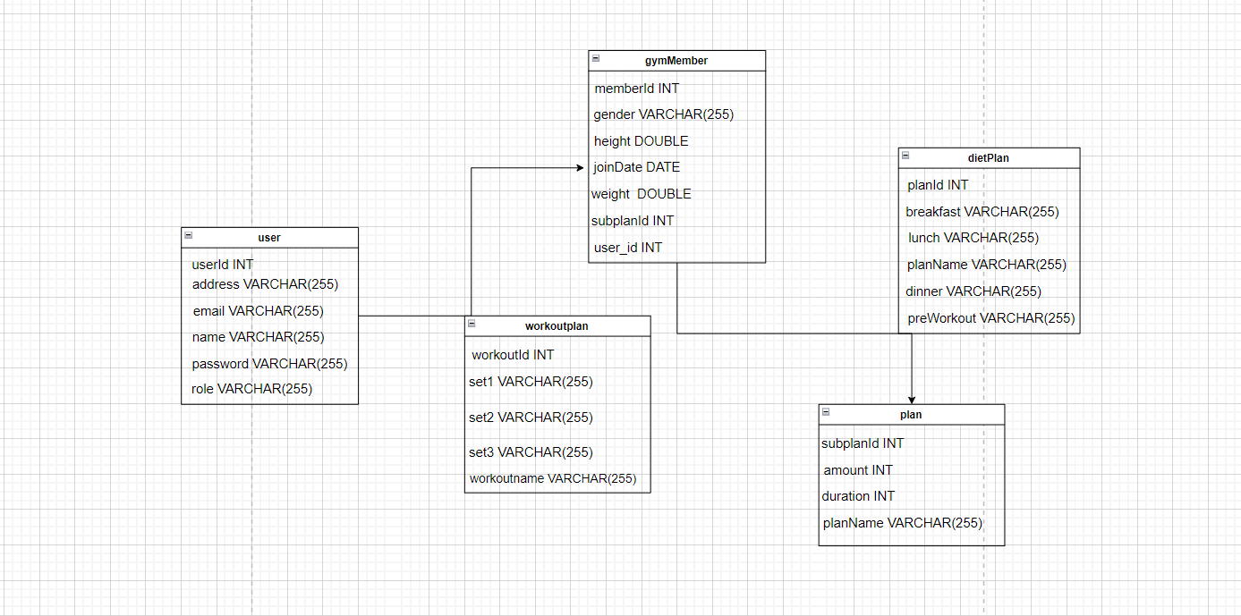

***Figure 9 Class Diagram***

# TABLE STRUCTURE:

## Tables:

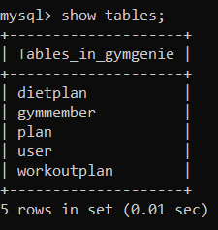

**User :**

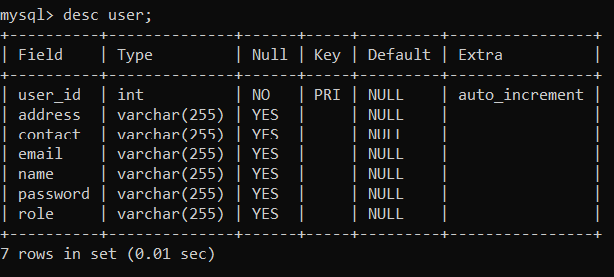

## Gym Member:

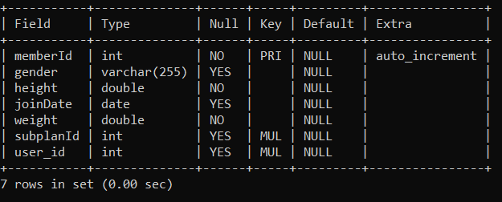

**Plan :**

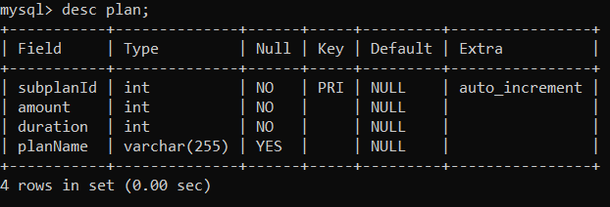

## Diet Plan :

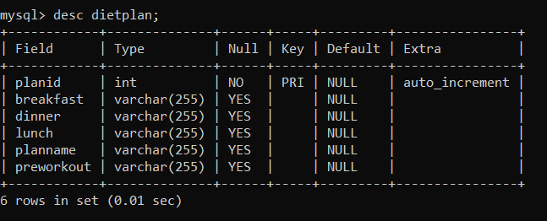

**Workout Plan:**

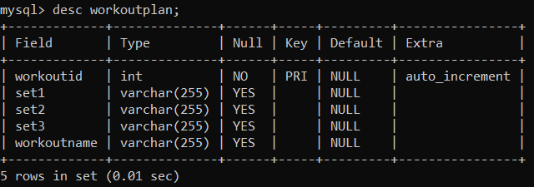

**SEQUENCE DIAGRAM**

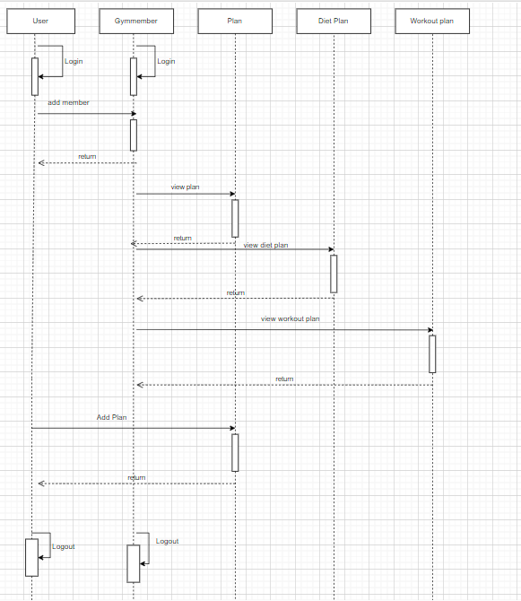

**USER CASE DIAGRAM**

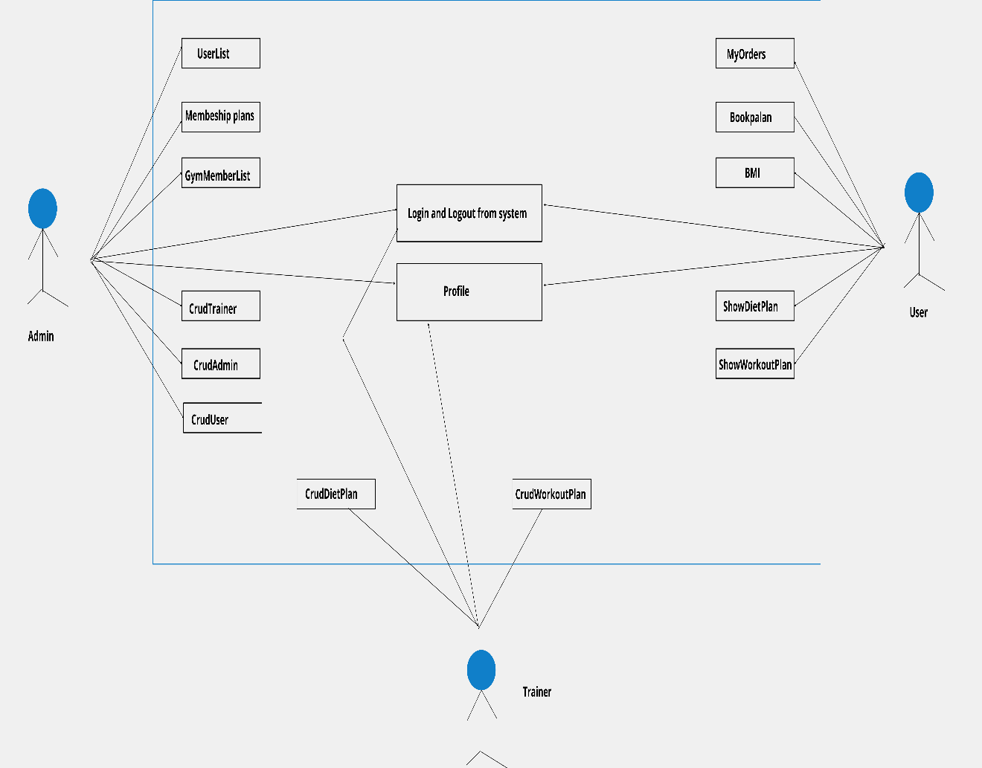

# PROJECT SNAPSHOTS

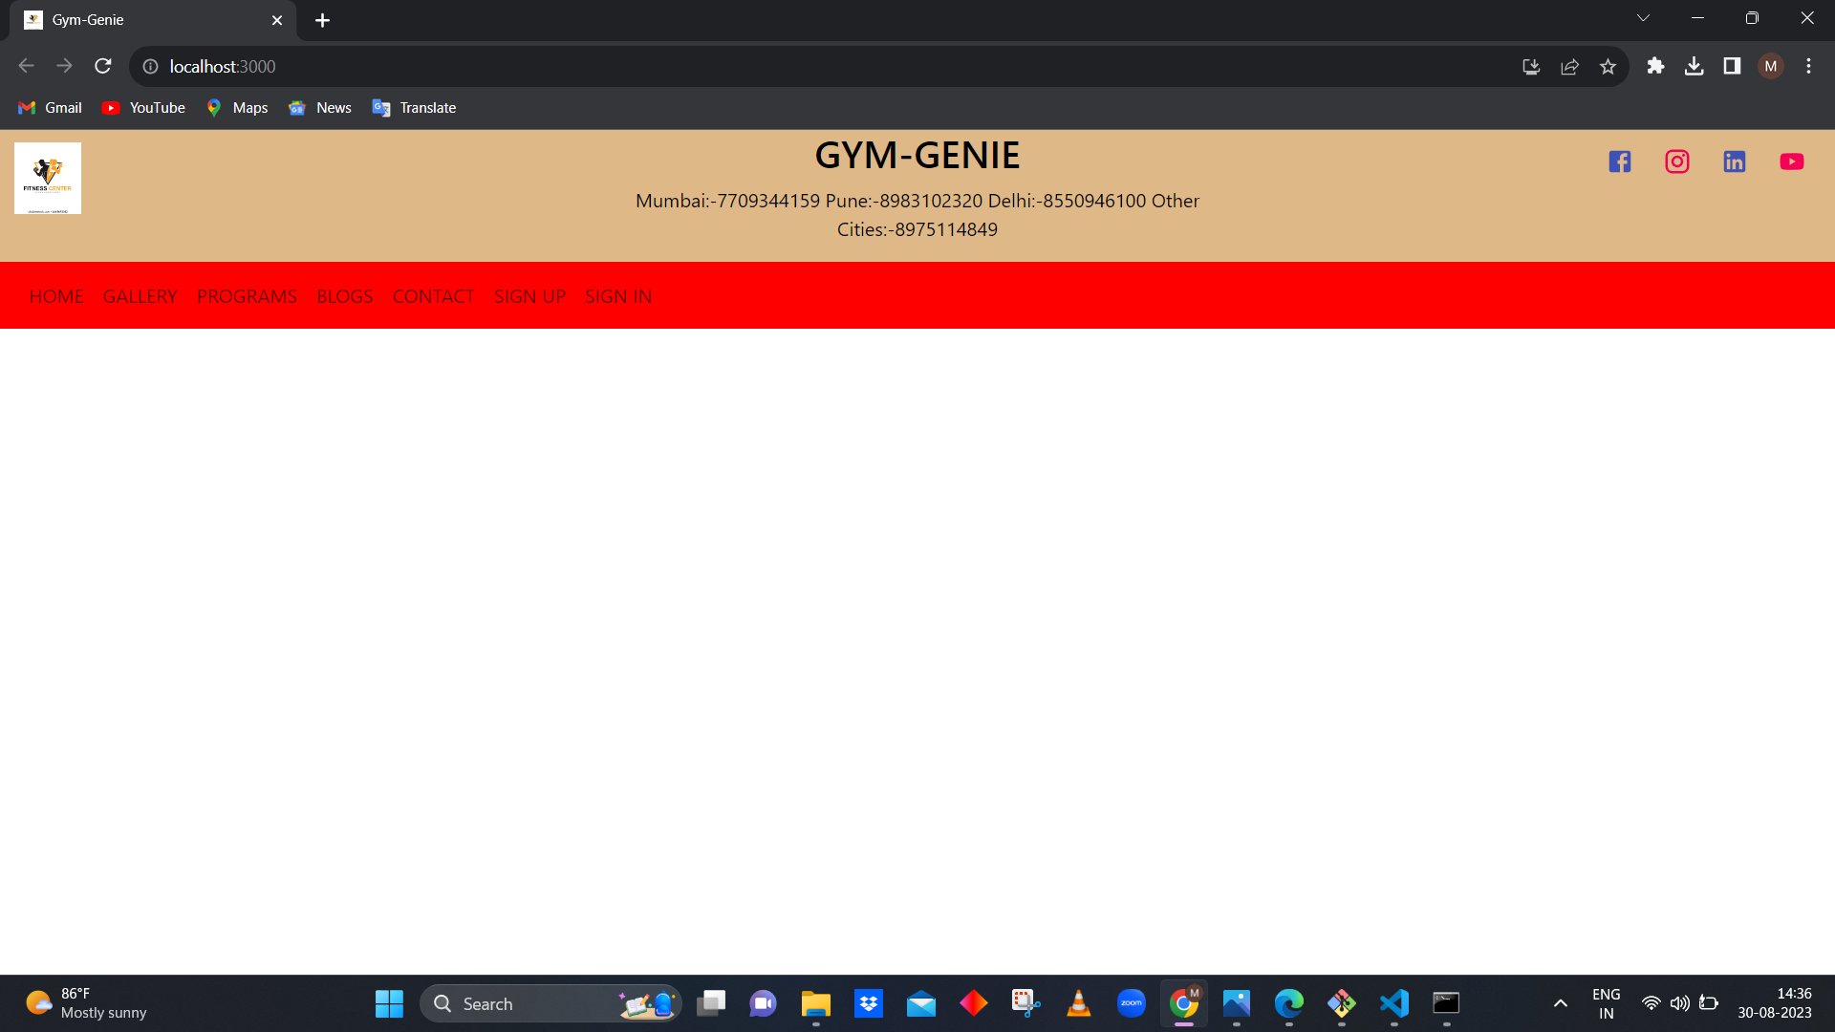

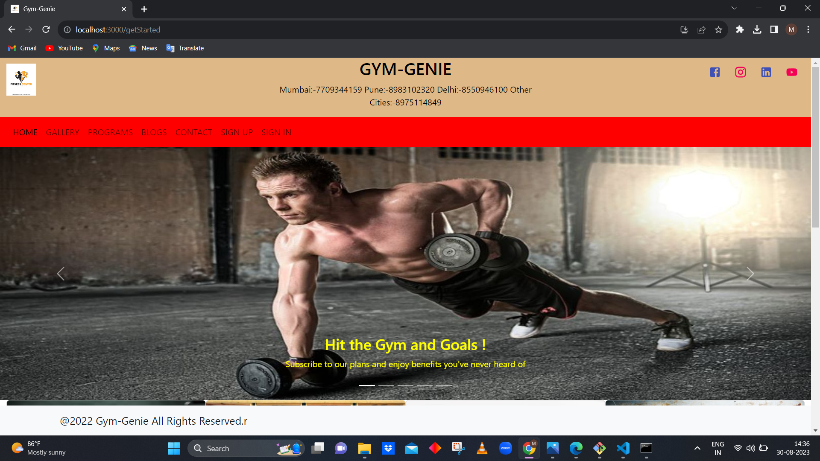

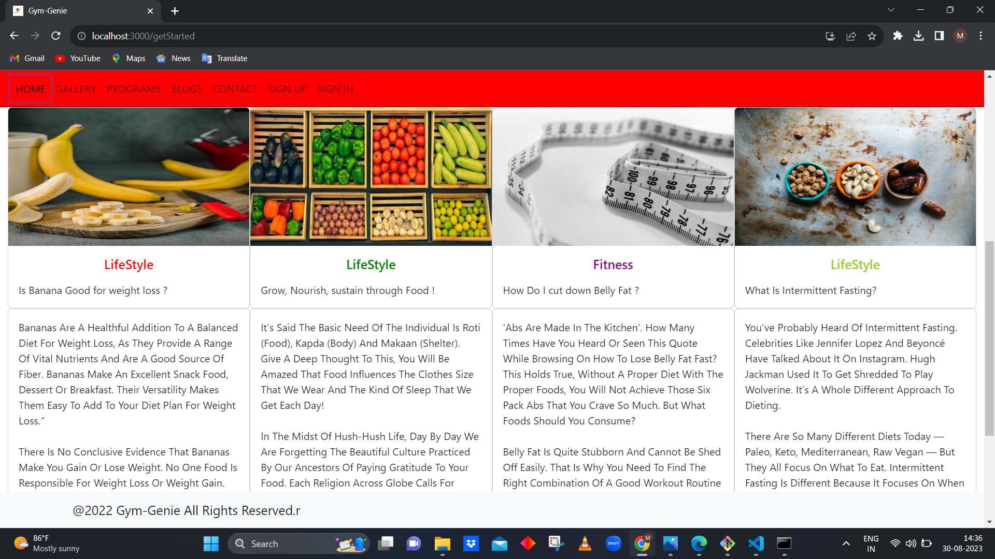

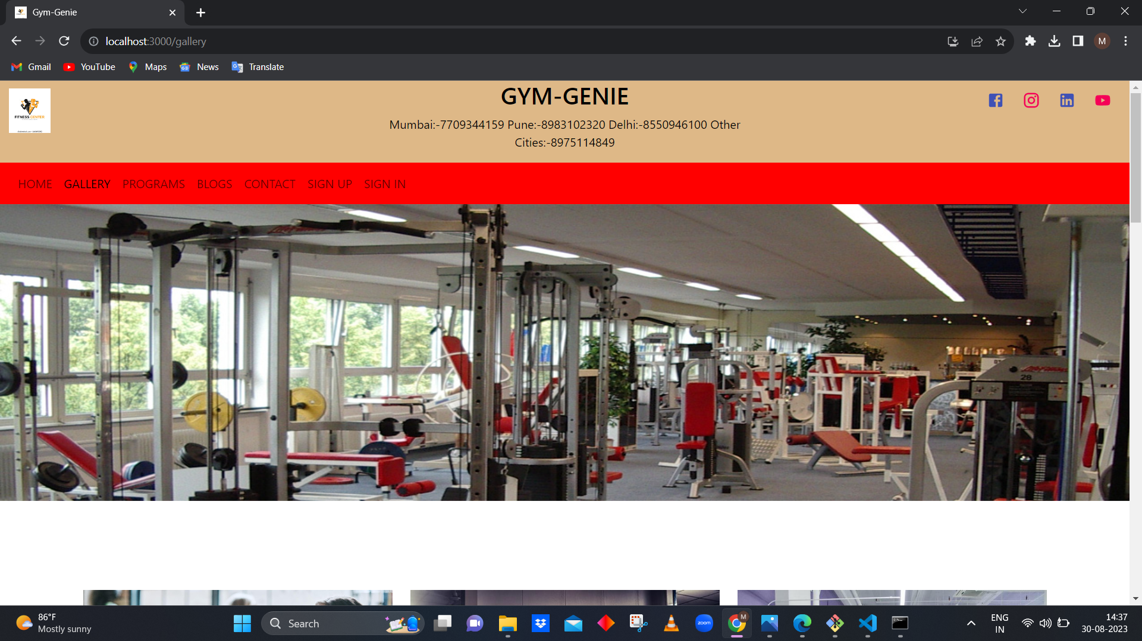

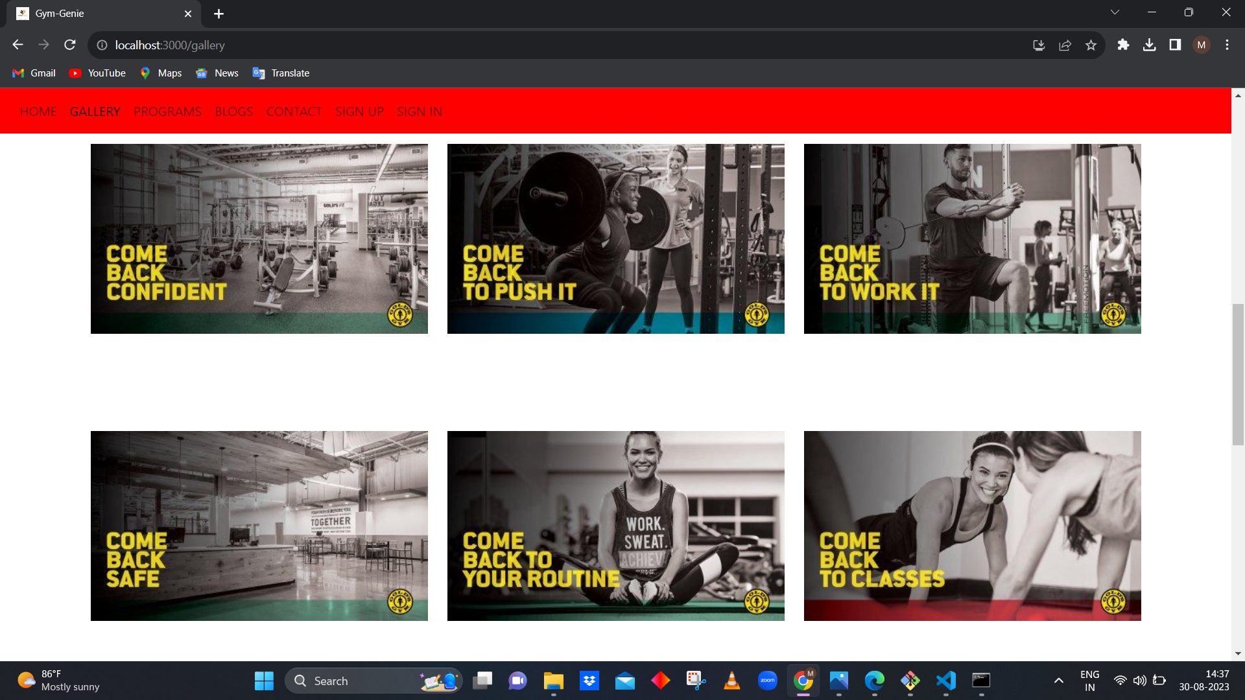

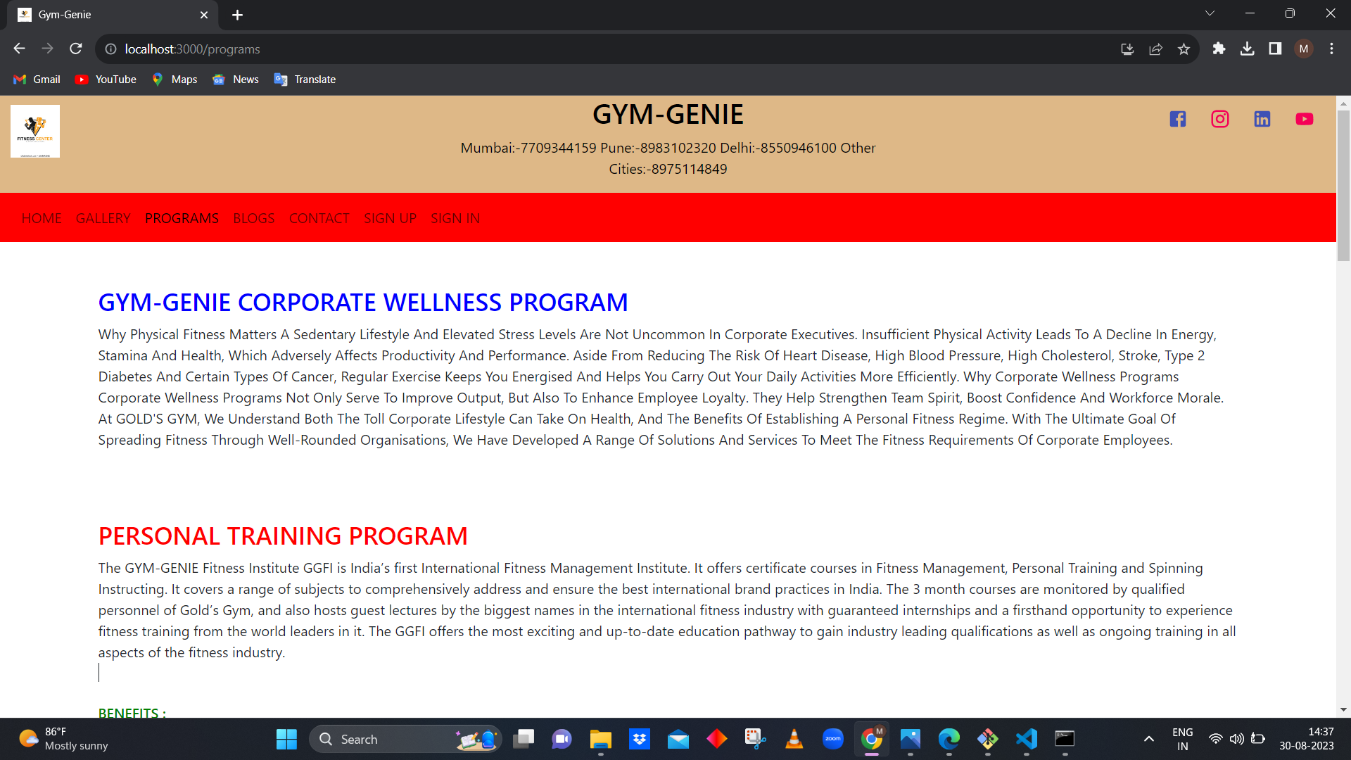

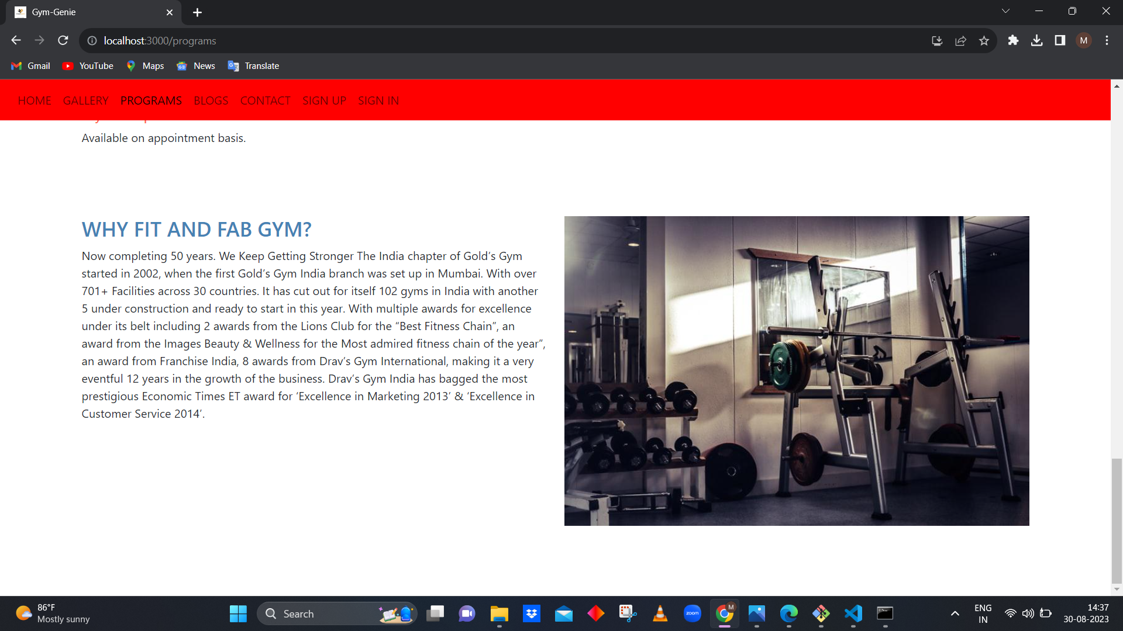

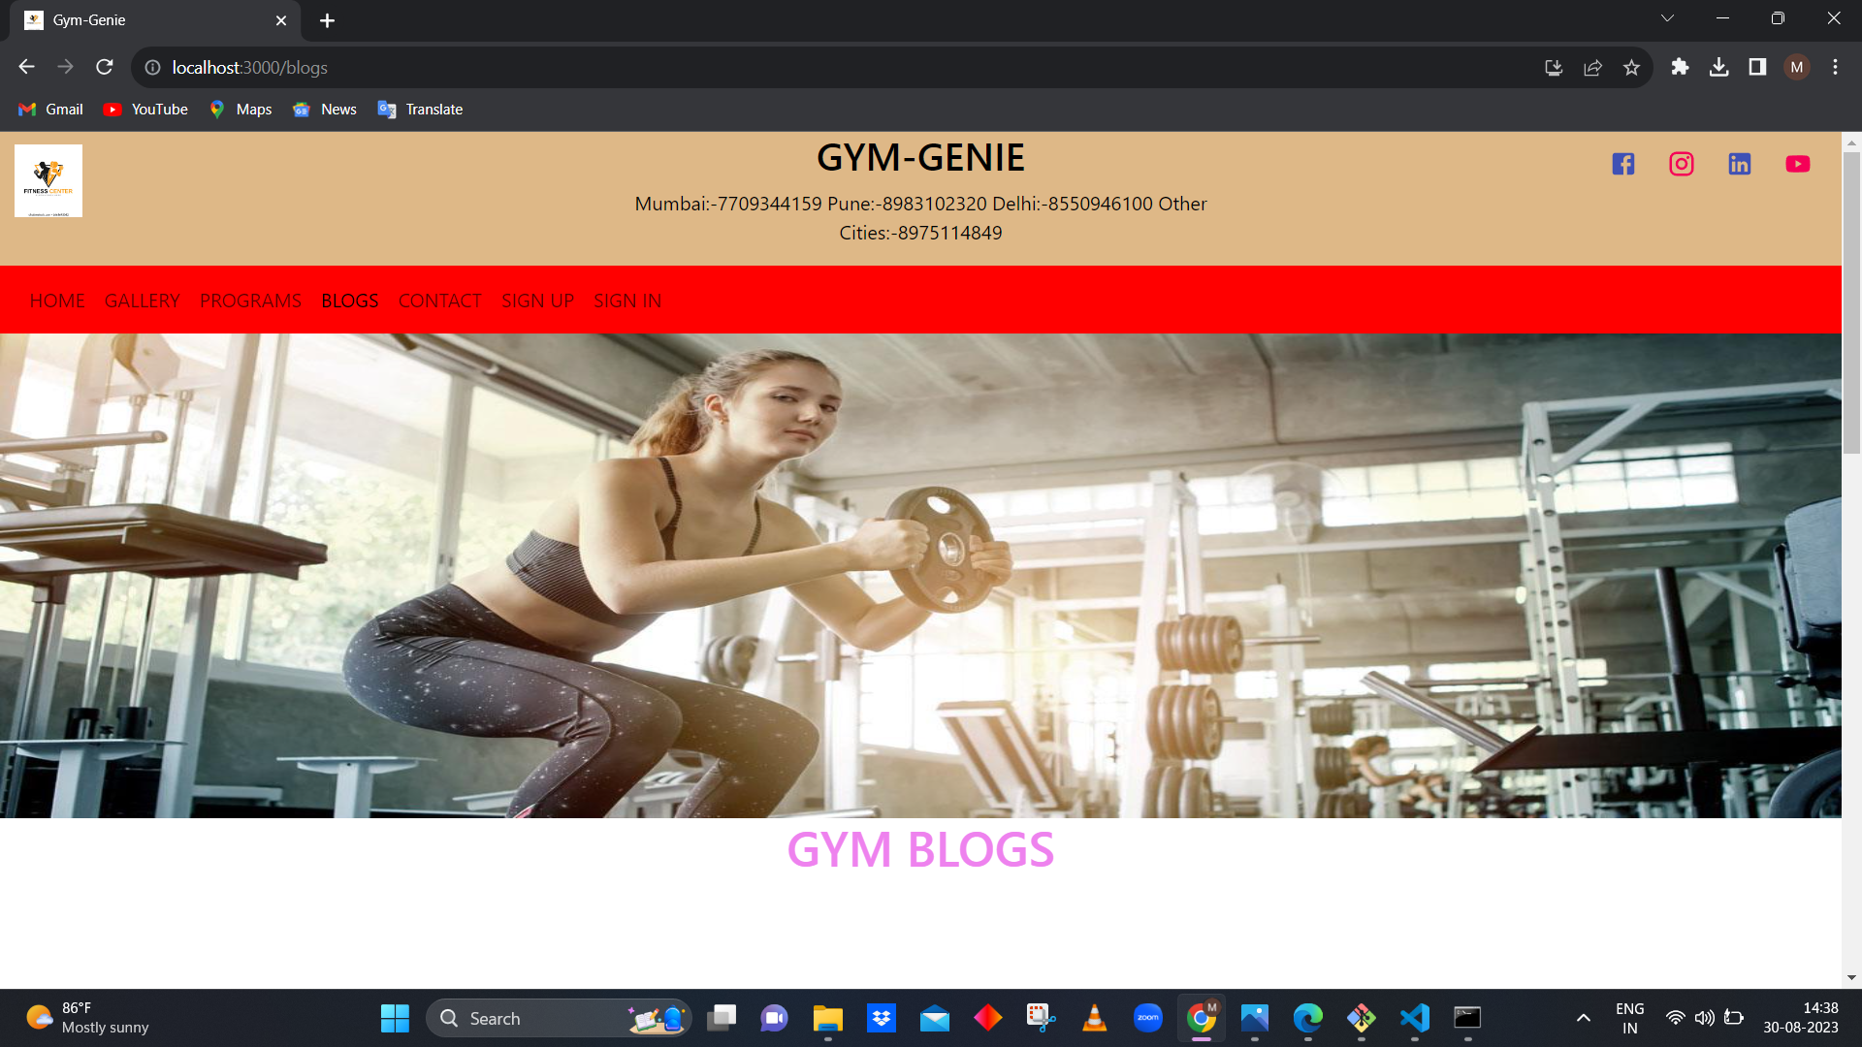

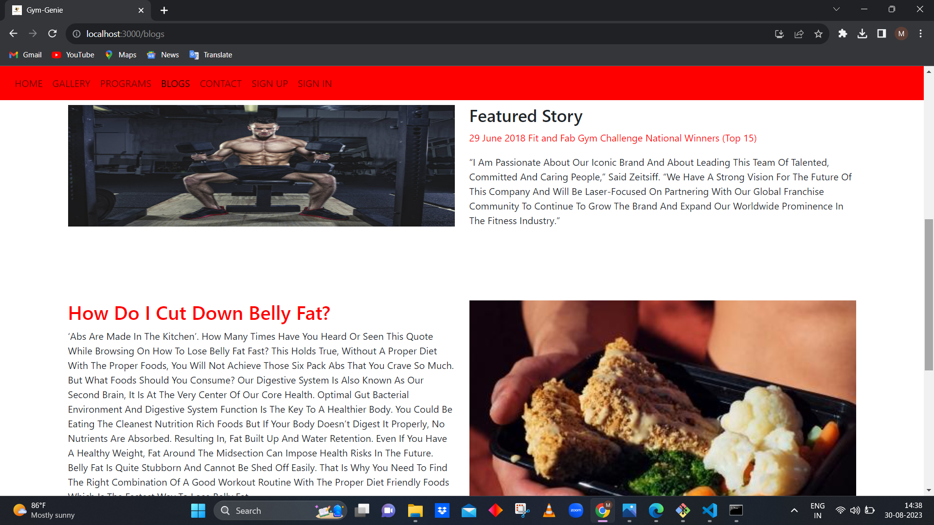



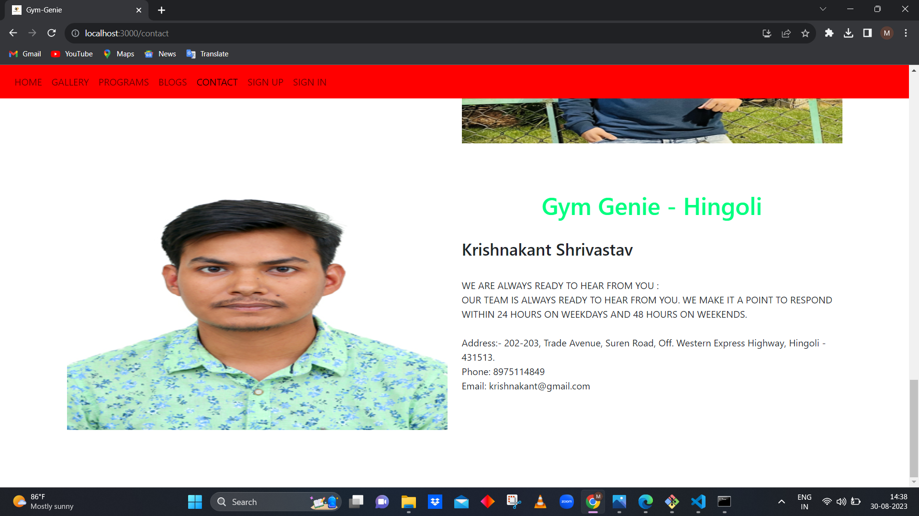

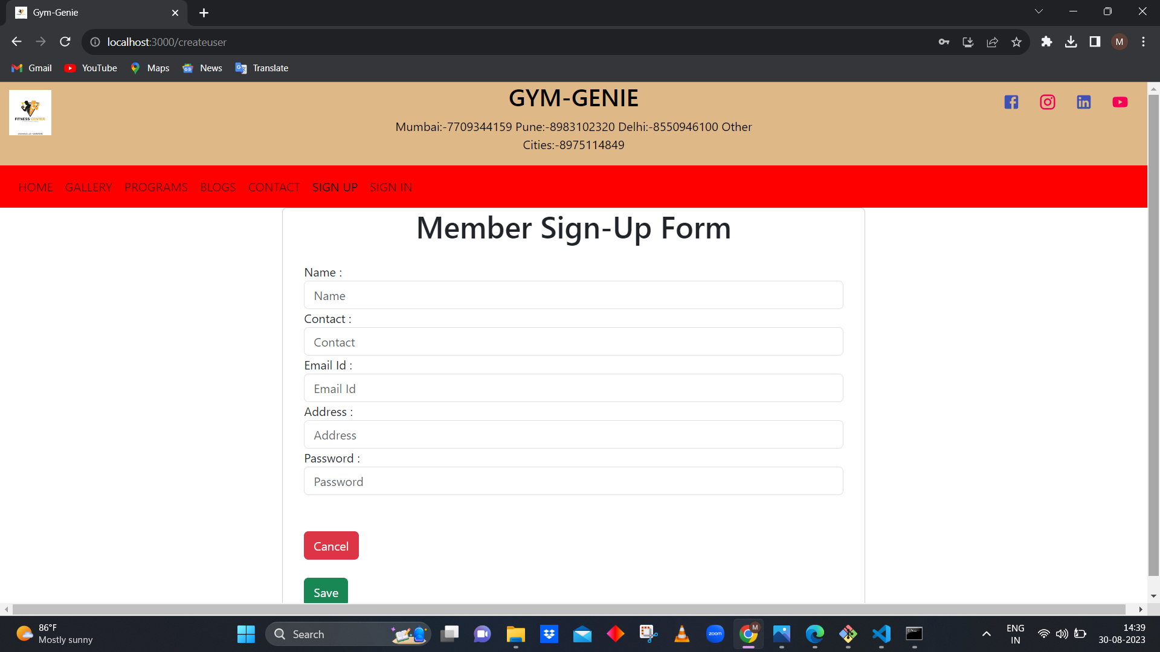

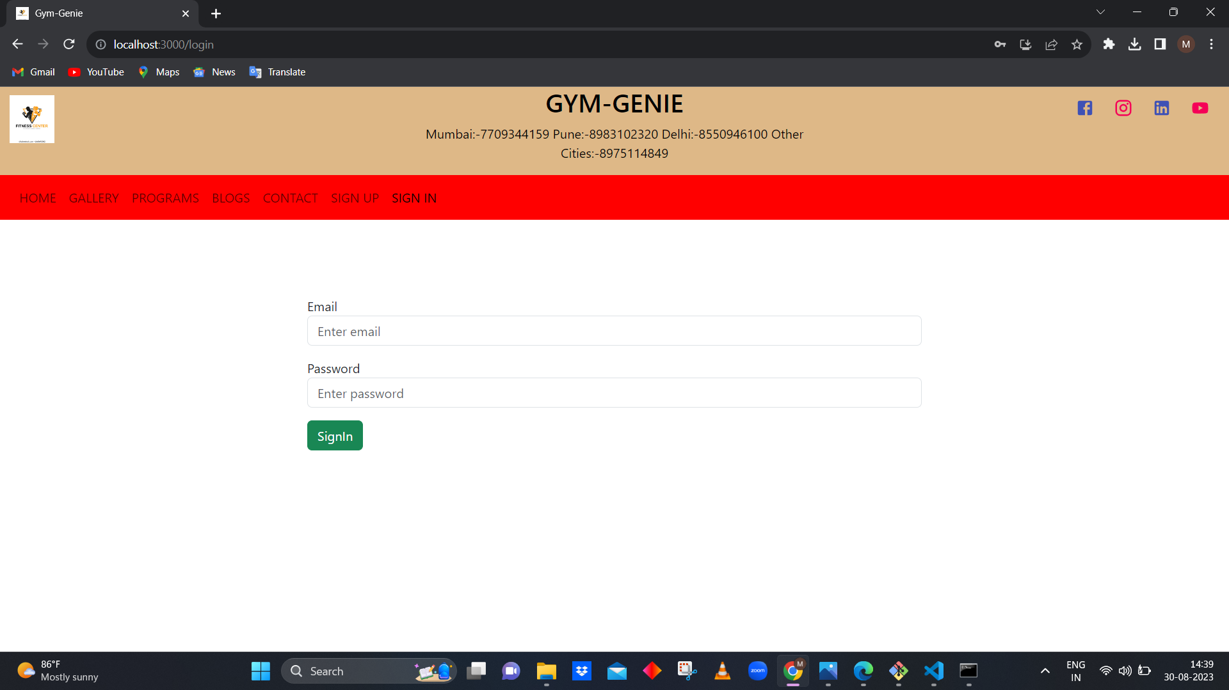

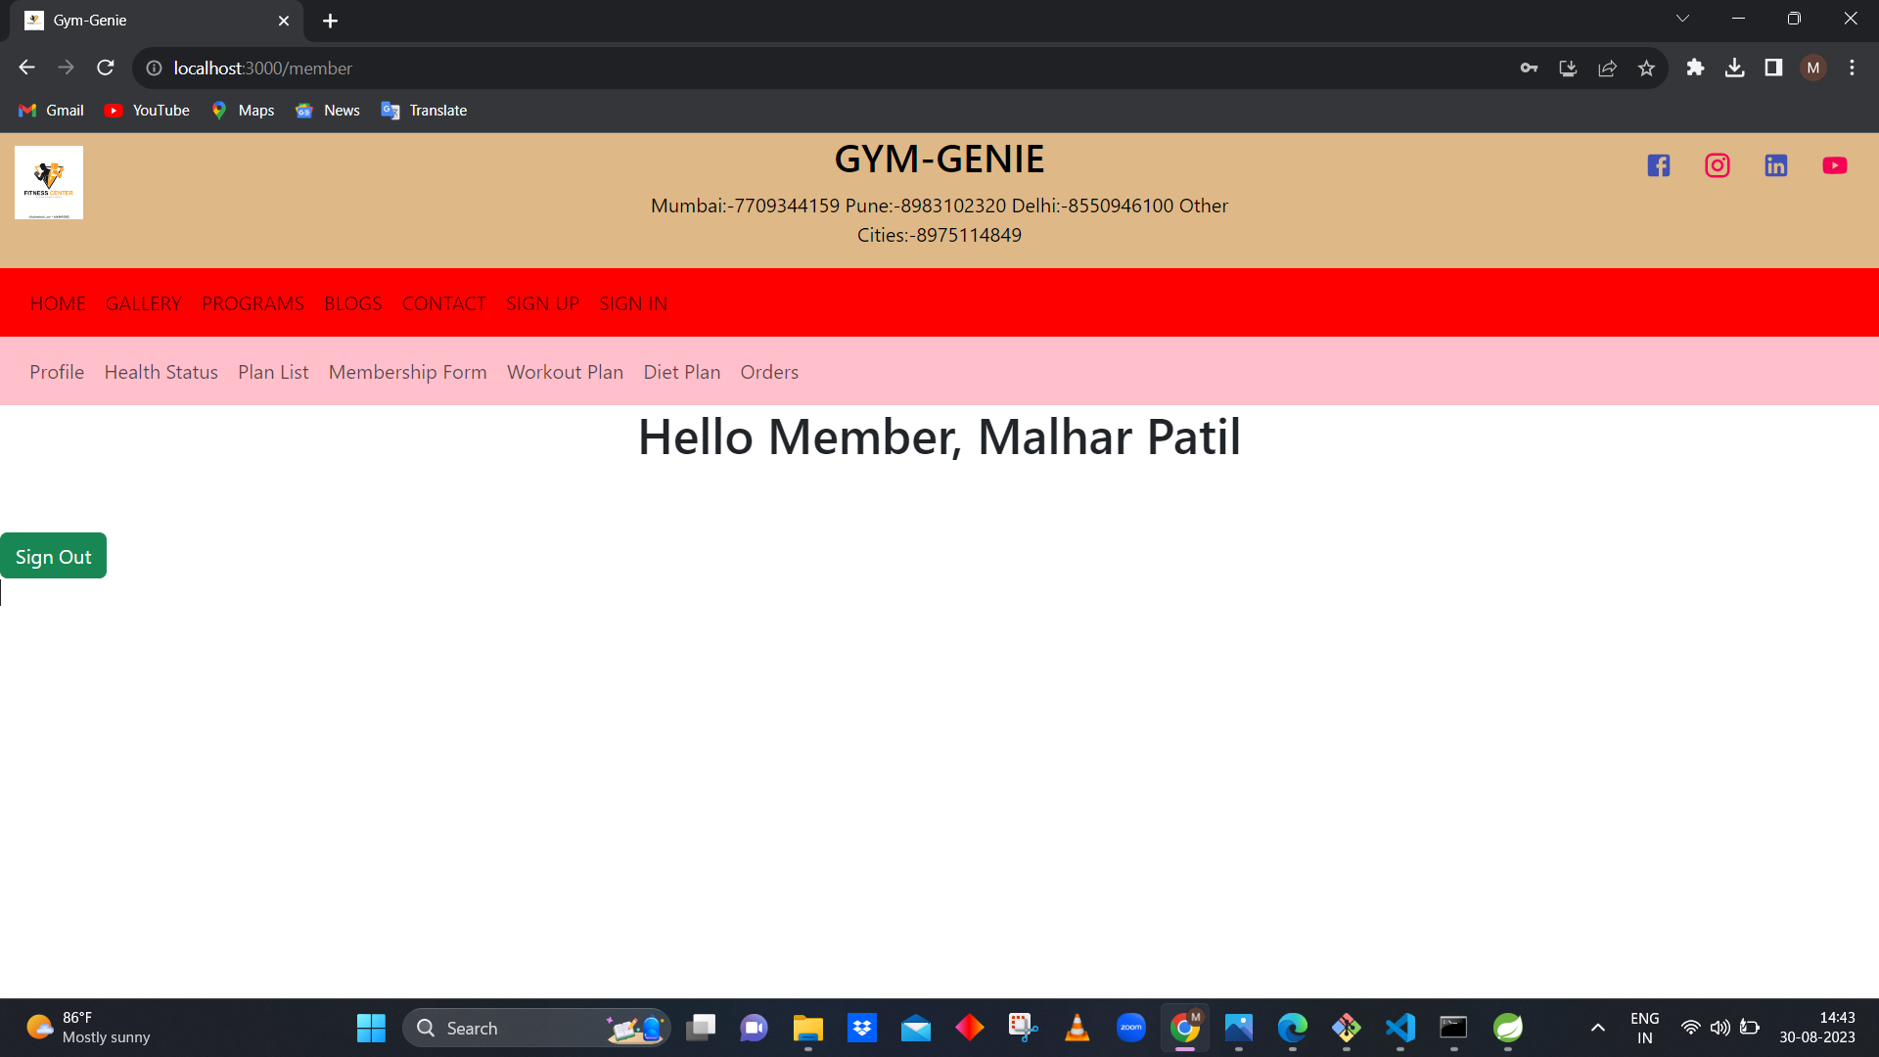

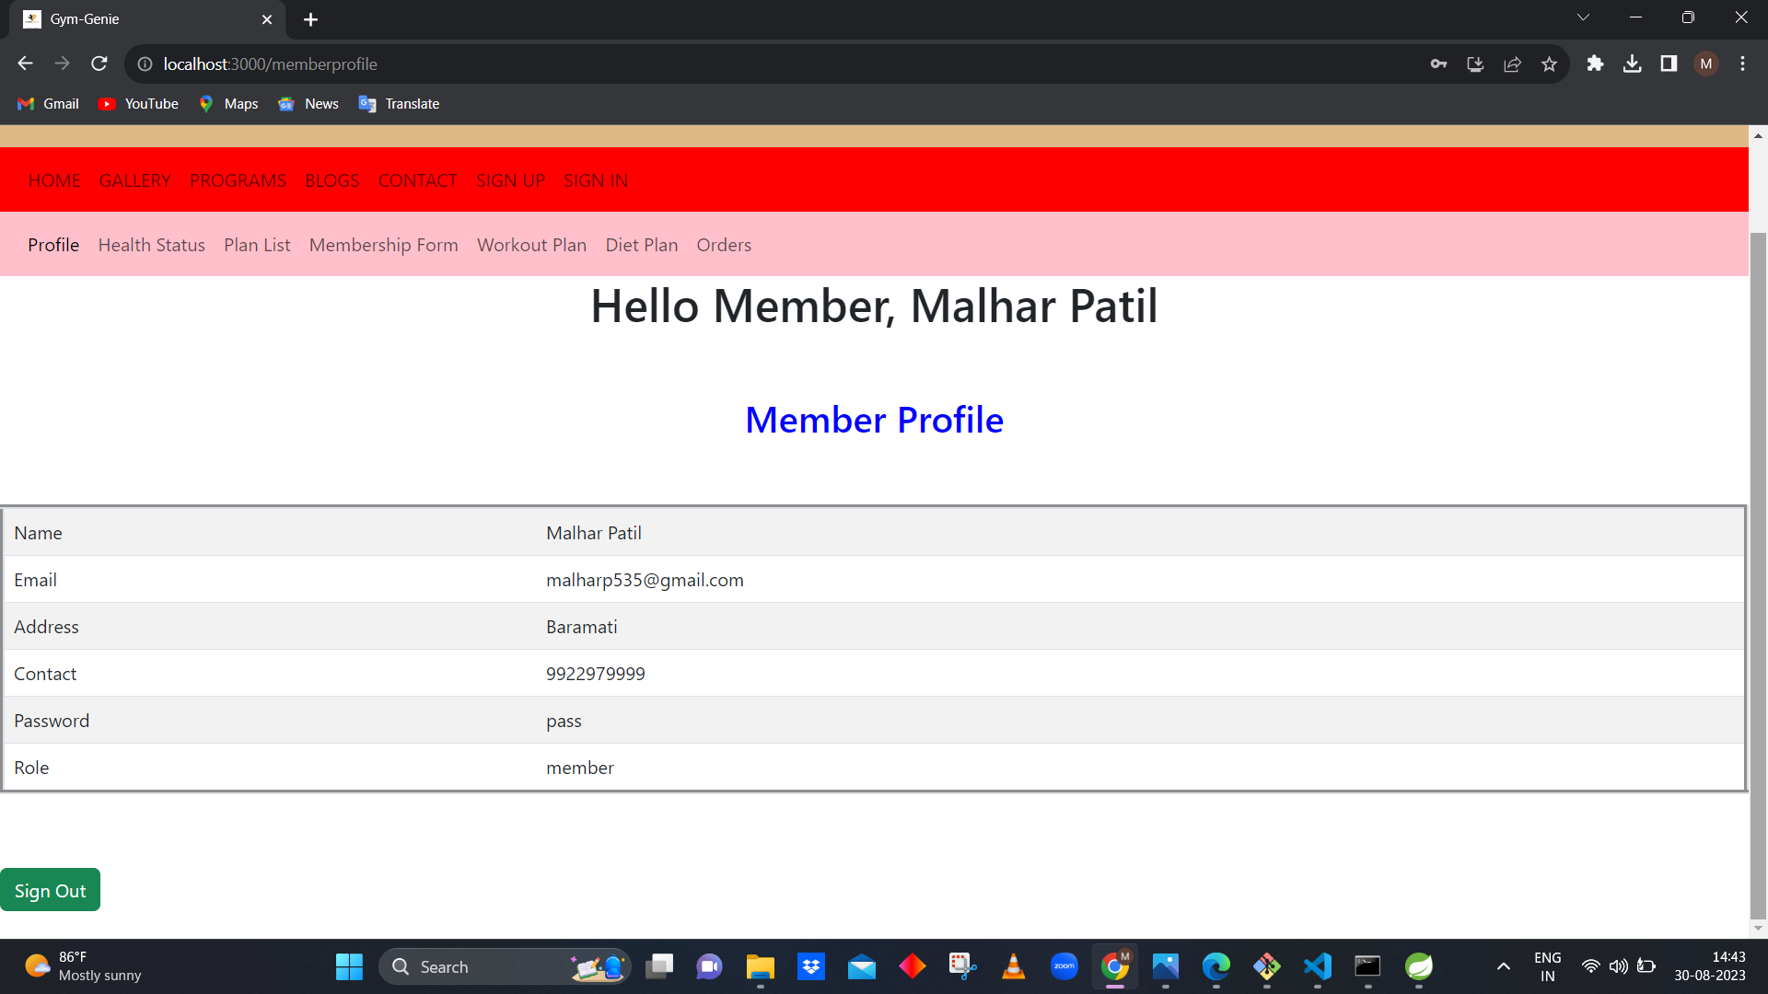

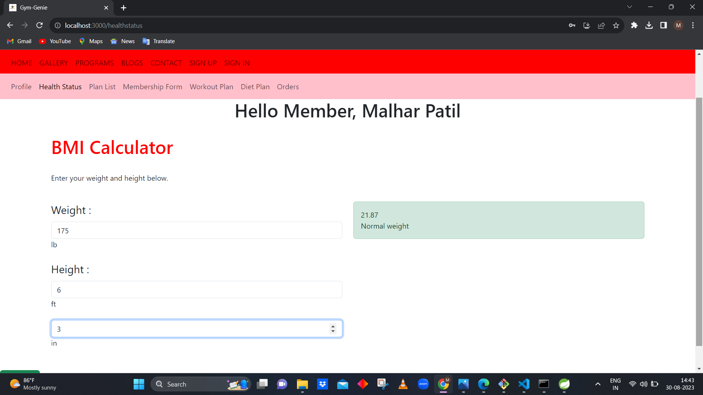

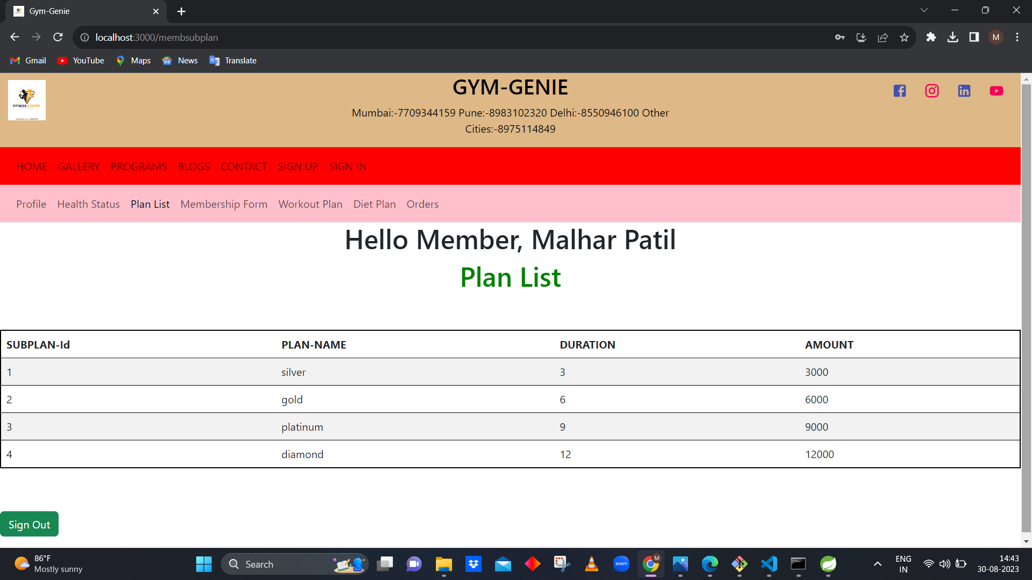

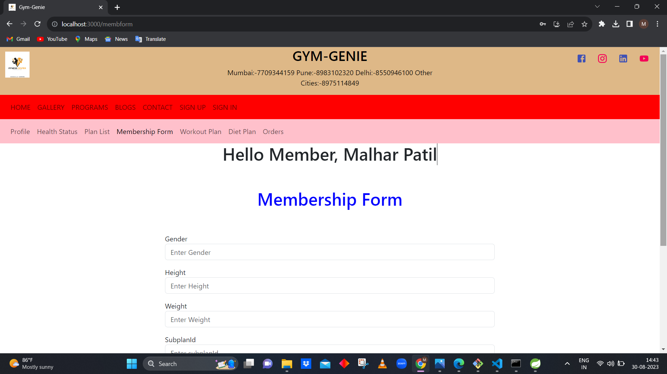

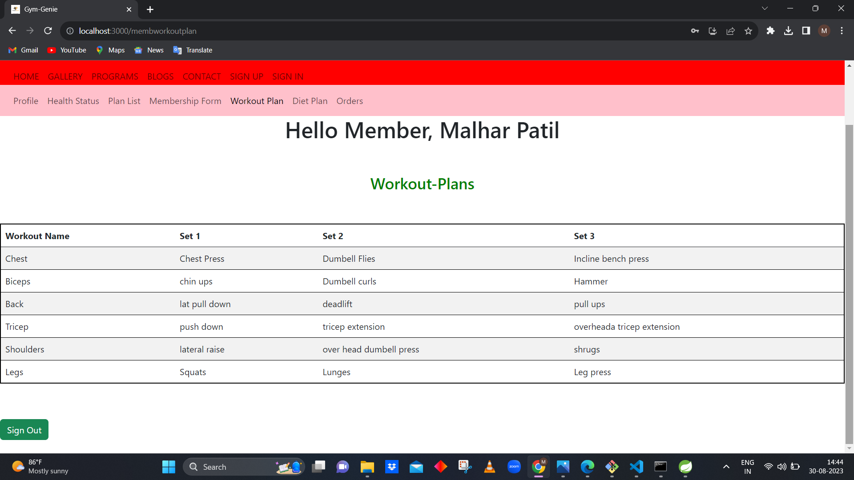

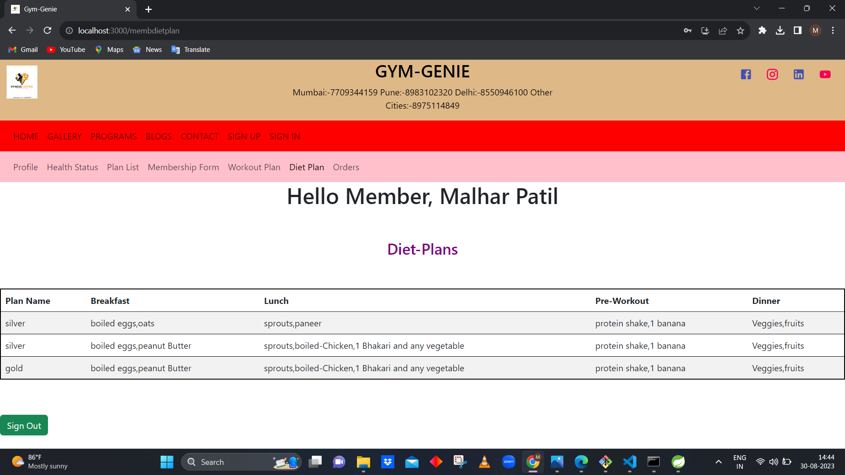

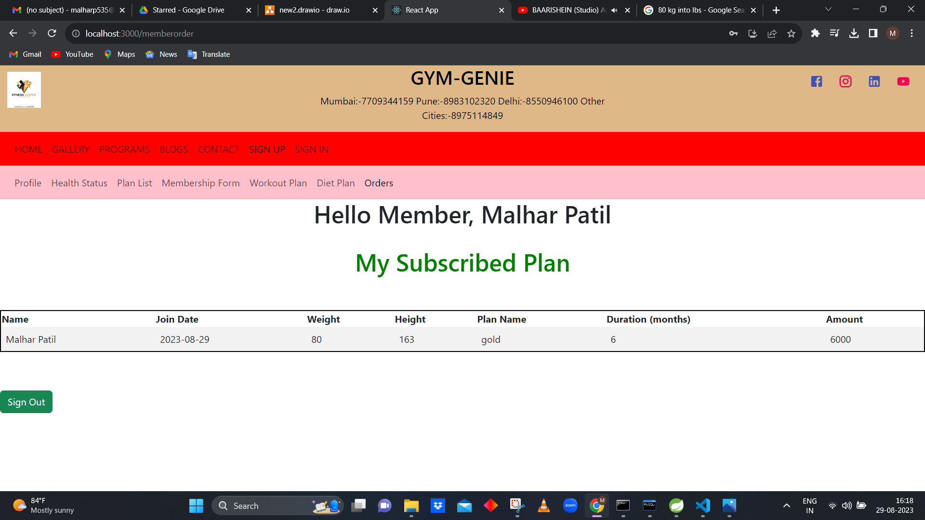

**FUTURE PROJECT SCOPE**

The future of gym management apps is likely to be shaped by technological advancements and changing user preferences. Apps will offer highly personalized experiences, tailoring workout plans, class recommendations, and content based on individual goals, fitness levels, and preferences. Gym apps could integrate AI to create dynamic workout routines that adapt in real-time based on user performance and feedback.  Users might engage in immersive VR workouts that simulate various environments, making exercise more engaging and enjoyable. AR can provide real-time guidance on proper form and technique, enhancing the quality of workouts and reducing the risk of injuries. Advanced biometric sensors in smartphones and wearables could provide detailed insights into users' health metrics, helping them monitor progress and make informed decisions.

# CONCLUSION

The project entitled **Gym Genie** was completed successfully.

The system has been developed with much care and free of errors and at the same time it is efficient and less time consuming. The purpose of this project was to develop a web application and an android application for a particular gym.

This project helped us in gaining valuable information and practical knowledge on several topics like designing web pages using React.js, usage of responsive templates, designing of android applications, and management of database using MySQL. The entire system is secured. Also, the project helped us understanding about the development phases of a project and software development life cycle. We learned how to test different features of a project.

This project has given us great satisfaction in having designed an application which can be implemented to any nearby shops or branded shops selling various kinds of products by simple modifications.

There is a scope for further development in our project to a great extent. A number of features can be added to this system in future like providing payment gateway for subscription payment and maintain their records in dashboard. Also wish to add each member profile with images store in data as well as bmi of users with their health information information in the system. These features could have implemented unless the time did not limit us.

# REFERENCES

1. JavaScript Enlightenment, Cody Lindley-First Edition, based on JavaScript 1.5, ECMA-262,

Edition

1. Mc Graw Hill’s, Java: The complete reference 7thEdition, Herbert Scheldt
2. Complete CSS Guide, Maxine Sherrin and John Allsopp-O'ReillyMedia; September 2012

## ONLINE REFERENCE

* 1. [www.Google.com](http://www.google.com/)
  2. [www.w3school.com](http://www.w3school.com/)
  3. [www.javatpoint.com](http://www.javatpoint.com/)
  4. [www.stackoverflow.com](http://www.stackoverflow.com/)
  5. [www.reactbootstrap.com](http://www.reactbootstrap.com/)
  6. [www.doc.spring.io/spring-framework.com](http://www.doc.spring.io/spring-framework.com)
  7. [www.geekforgeeks.com](http://www.geekforgeeks.com/)
  8. [www.microsoftdoc.com](http://www.microsoftdoc.com/)
  9. [www.geeksforpratice.com](http://www.geeksforpratice.com/)